SUMMER SCHOOL PROGRAM
Certified Program in Financial Literacy & Indian Securities Markets
Offered by SGT University
In Academic Collaboration with LexFin

About the Program
SGT University, in collaboration with LexFin, presents a comprehensive Summer School Program designed to cultivate financial awareness and practical competencies among school students.
This structured residential certification program, available in 4-week and 7-week formats, is carefully curated to provide a balanced blend of academic instruction and experiential learning. The program integrates classroom teaching, simulation-based learning, institutional exposure, and expert-led sessions to deliver a well-rounded understanding of financial systems and markets.
The initiative aims to equip students with essential financial life skills, enabling them to make informed decisions in an increasingly complex economic environment.

Program Objectives
- To develop foundational financial literacy and awareness
- To enhance practical money management and decision-making skills
- To introduce students to the structure and functioning of financial institutions and markets
- To foster responsible financial behavior and discipline
- To provide early exposure to finance-related career pathways

Program Highlights
Comprehensive Financial Literacy
Participants will gain structured knowledge of:
- Personal finance and wealth management
- Investment awareness and risk understanding
- Fundamentals of Indian financial markets

Skill Development & Certification
- Industry-aligned curriculum
- Practical skill enhancement through applied learning
- Formal Certification upon successful completion

Experiential Learning Framework
- Simulation-based financial labs
- Case study analysis and real-world applications
- Data-driven learning using financial tools and Excel

Institutional Exposure
Participants will be introduced to the roles and functioning of key institutions such as:
- Reserve Bank of India
- Securities and Exchange Board of India
- Stock exchanges and financial market infrastructure institutions

Expert Engagement & Networking
- Interactive sessions with domain experts and academicians
- Exposure to professionals from banking, finance, and capital markets
- Opportunities for academic and professional networking

Curriculum Overview
The curriculum is designed to provide a progressive and application-oriented learning experience, structured across the following modules:

Module 1: Money and Financial Foundations
- Evolution of money: barter to digital systems
- Types of money: coins, paper, plastic, and electronic
- Economic significance of money

Module 2: Banking and Financial Systems
- Structure and role of banking institutions
- Types of banks and services offered
- Deposits, loans, and account management
- KYC norms and regulatory compliance
- Digital banking and transaction systems
- Interest calculations and compounding principles
- Loan structures and EMI calculations
- Introduction to foreign exchange
- Credit systems (CIBIL) and financial credibility
- Regulatory role of RBI

Module 3: Behavioral Finance and Financial Responsibility
- Needs vs. wants and consumption behavior
- Financial discipline and responsible spending
- Risks of impulsive borrowing and debt management
- Ethical considerations including insider trading
- Importance of taxation and financial accountability

Module 4: Financial Planning and Life-Cycle Management
- Principles of financial planning
- Budgeting and goal setting
- Planning across life stages:
  - Education and career
  - Asset acquisition (house/vehicle)
  - Family and social responsibilities
  - Retirement planning
- Emergency and contingency planning

Module 5: Technology in Finance
- Digital financial systems and safety protocols
- Online banking, NEFT/RTGS, ATM operations
- Introduction to online trading platforms
- Structure and functioning of stock exchanges
- Demat accounts and depository systems
- Basics of algorithmic trading
- Financial applications using Excel

Module 6: Financial Documentation and Compliance
- Importance of maintaining financial records
- PAN, Aadhaar, and regulatory documentation
- Banking records and insurance documentation
- Tax compliance and record-keeping
- Awareness of grievance redressal mechanisms

Curriculum Structure with Visual Learning Aids

Module 1: Money and Financial Foundations
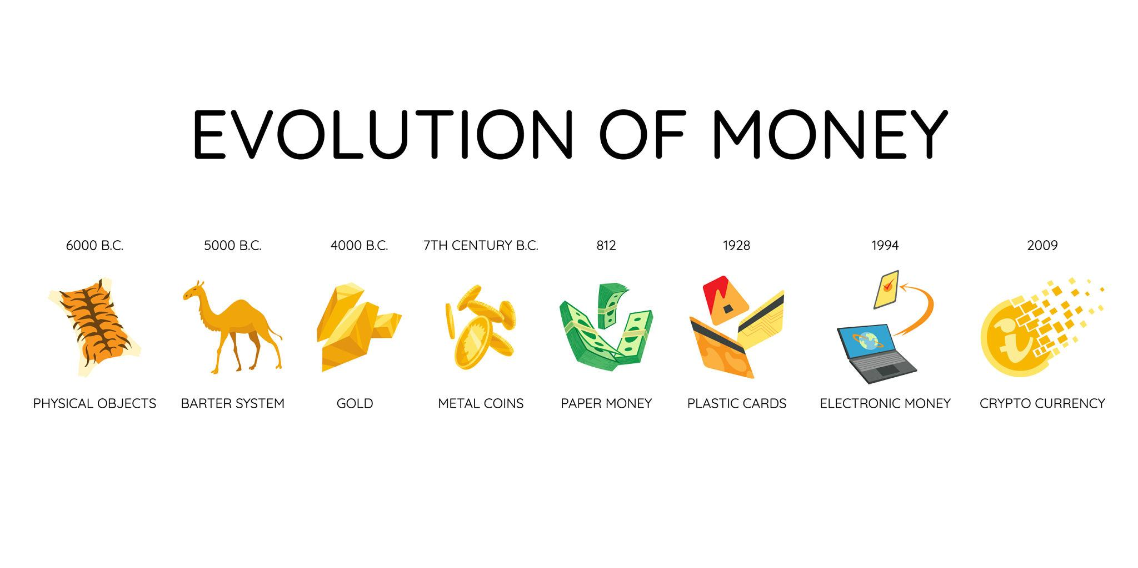
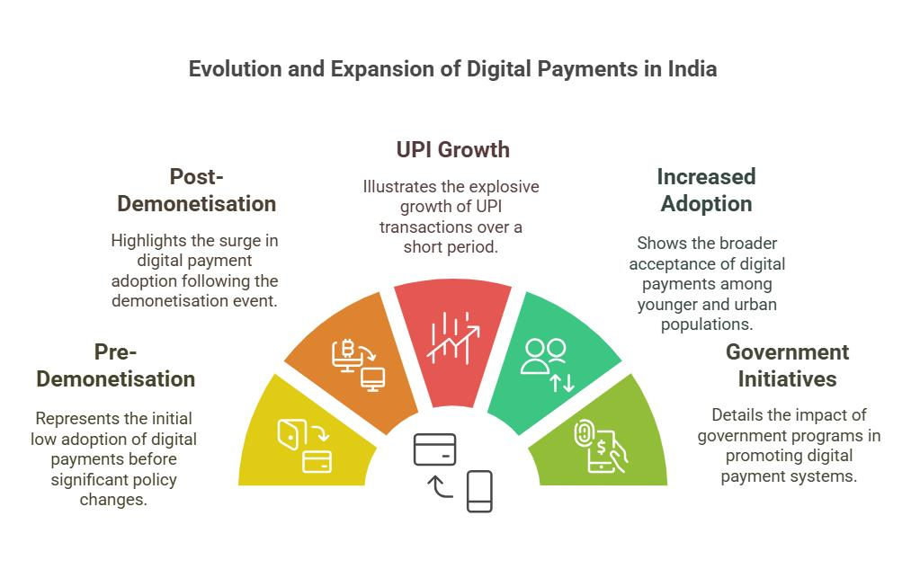
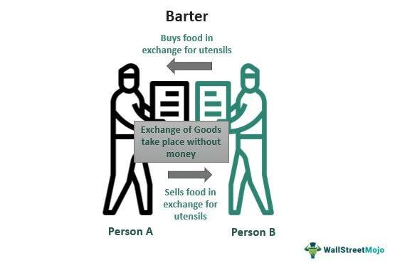
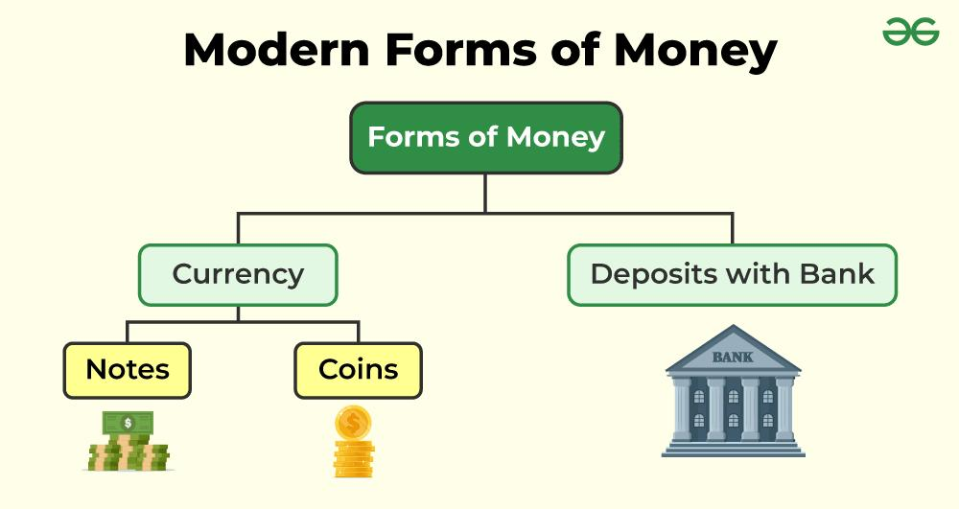
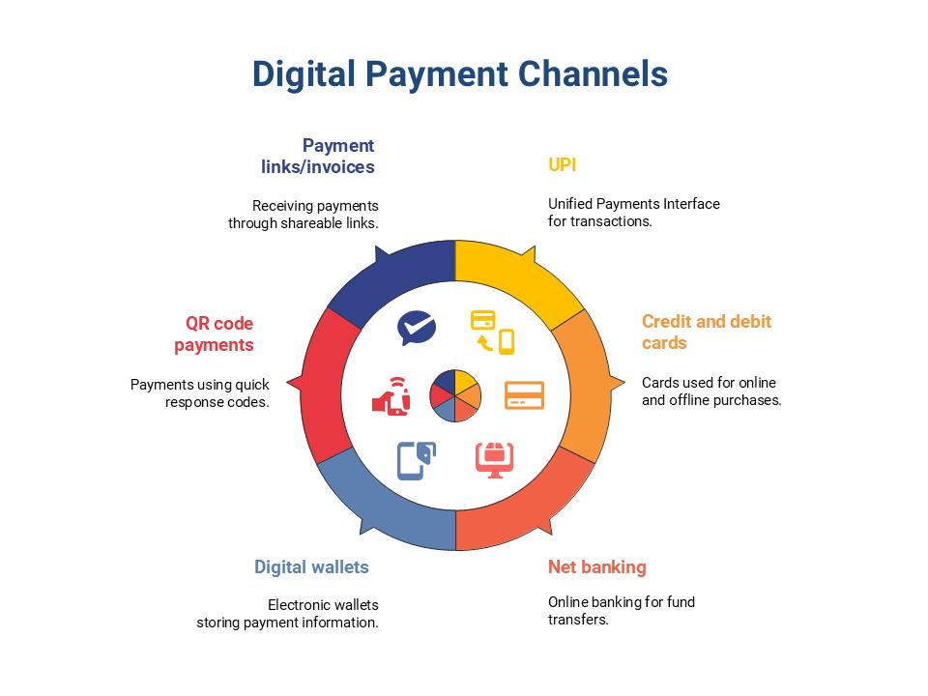
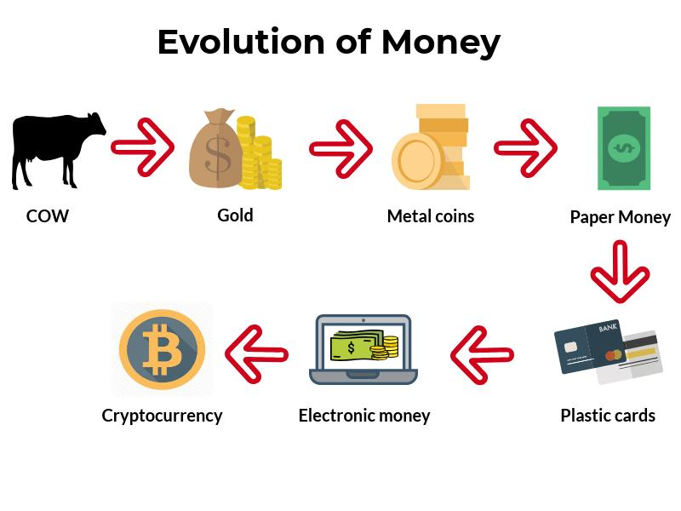
Key Concepts
- Evolution of money: Barter → Coins → Paper → Digital
- Types of money: Coins, Paper, Plastic, E-Money
- Economic significance of money
Flowchart: Evolution of Money
Barter System → Commodity Money → Metallic Coins → Paper Currency → Plastic Money → Digital Payments (UPI, Cards)
Diagram Insight
Money acts as:
Medium of Exchange
↓
Store of Value
↓
Unit of Account

Module 2: Banking and Financial Systems
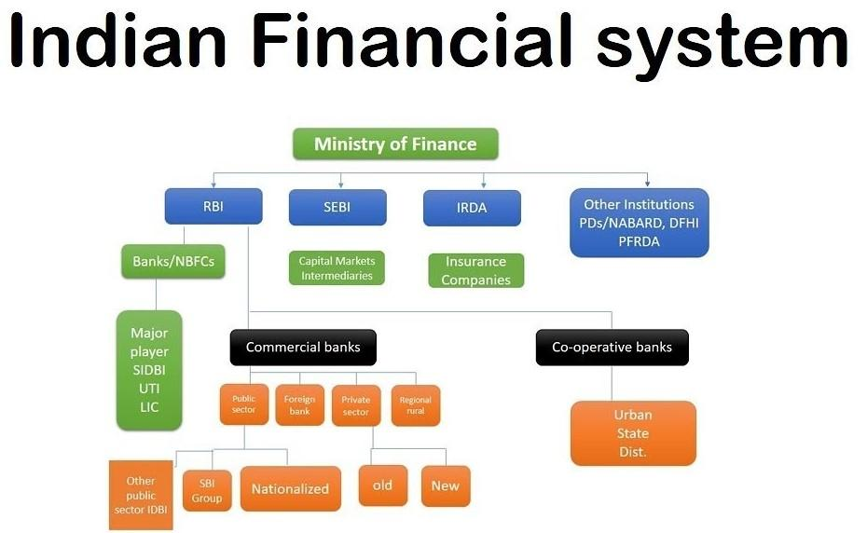
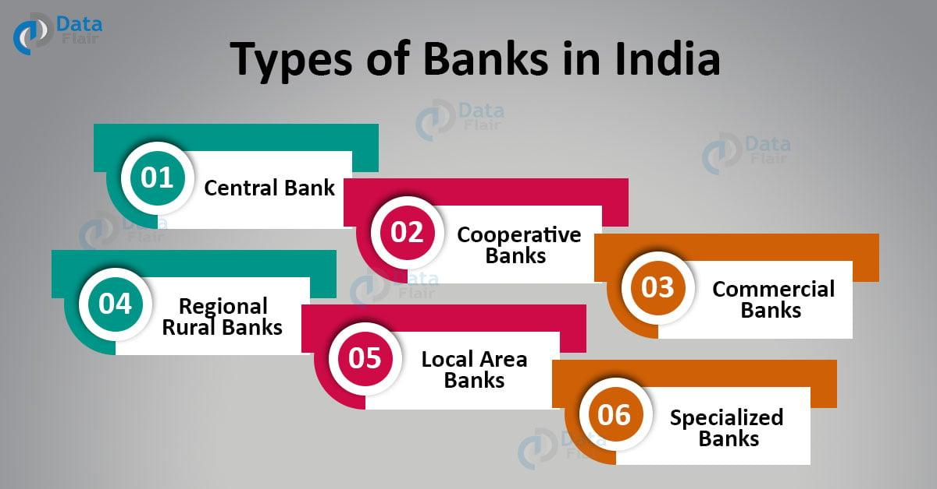
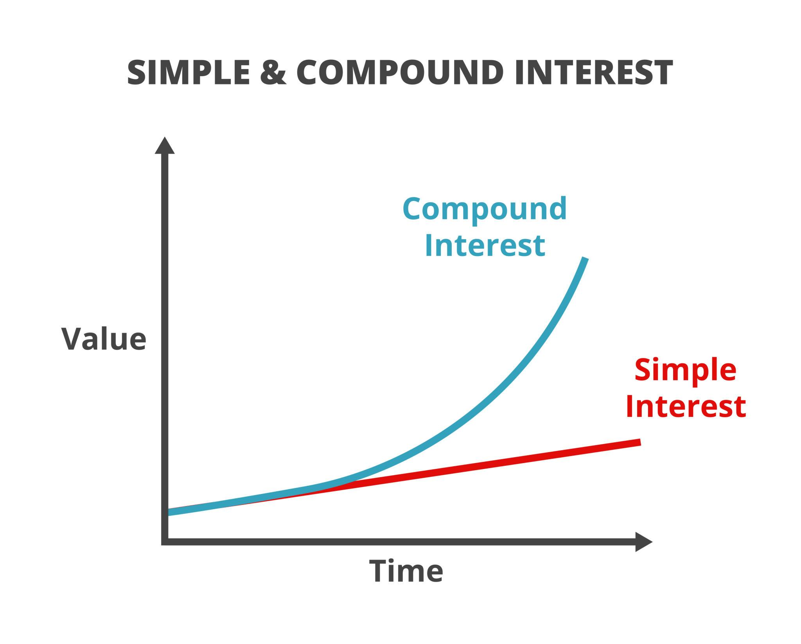
Key Concepts
- Structure and role of banks
- Deposits, loans, accounts
- KYC norms & digital banking
- Interest, EMI, foreign exchange
- CIBIL & RBI
Flowchart: Banking Process
Customer → Opens Account (KYC) → Deposits Money → Bank Lends Money → Earns Interest → Economic Growth
Diagram: Interest Types
Simple Interest → Fixed on Principal
Compound Interest → Interest on Interest (Growth ↑↑)
Diagram: Loan & EMI
Loan Amount → Interest Rate → Time Period → EMI Calculation → Monthly Payment

Module 3: Behavioral Finance & Financial Responsibility

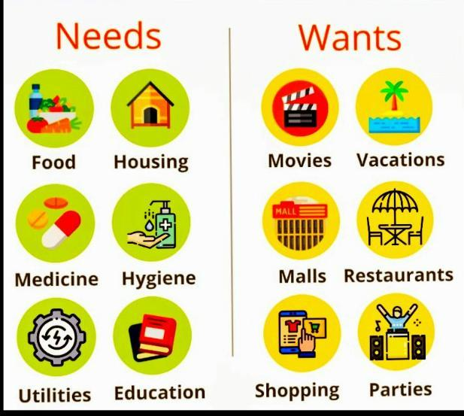
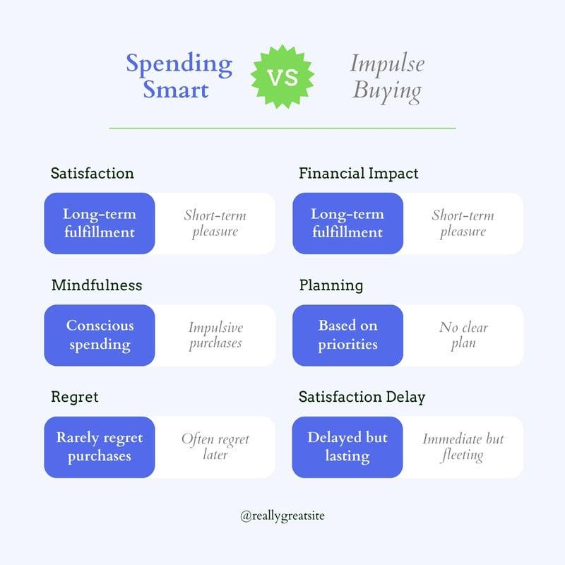

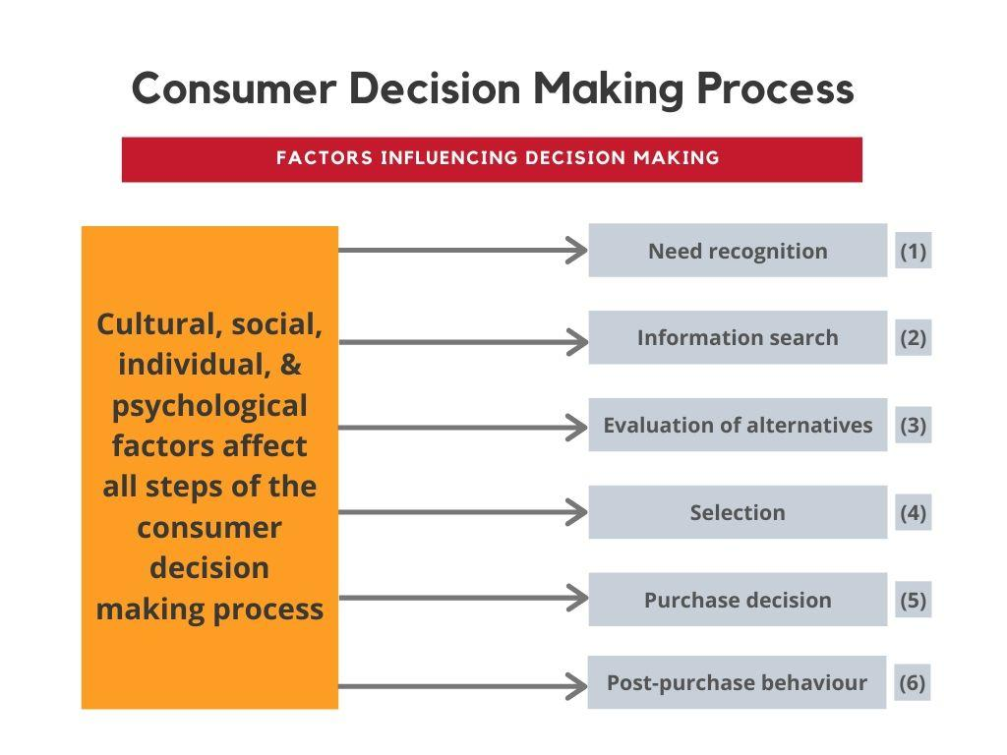
Key Concepts
- Needs vs Wants
- Responsible spending
- Debt management
- Ethics & taxation
Flowchart: Financial Decision Making
Income → Needs → Savings → Investments → Wants (if surplus)
Diagram: Spending Behavior
Impulsive Spending ❌ → Debt → Stress
Planned Spending ✅ → Savings → Wealth Creation

Module 4: Financial Planning & Life-Cycle Management
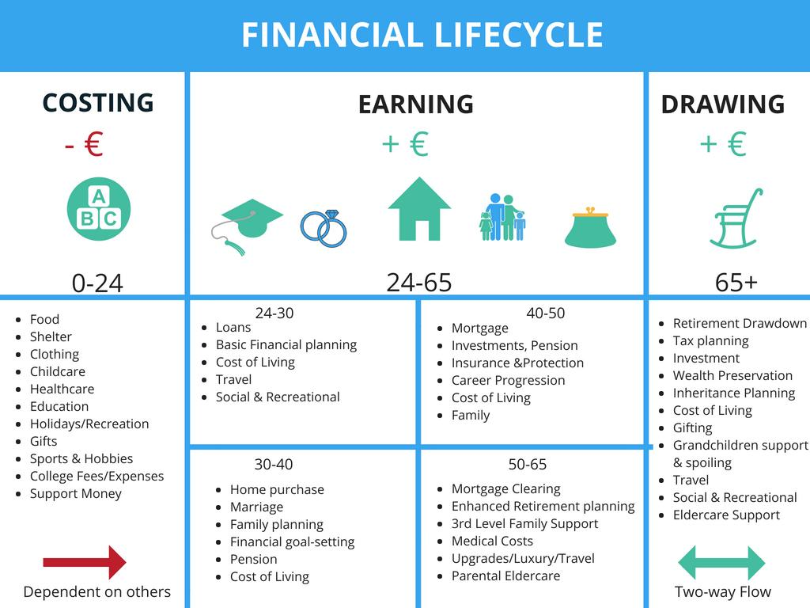
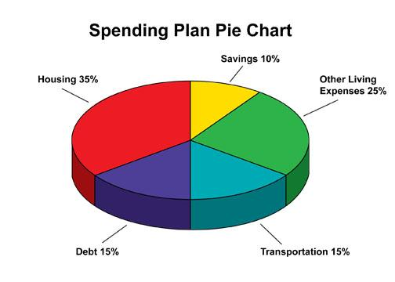
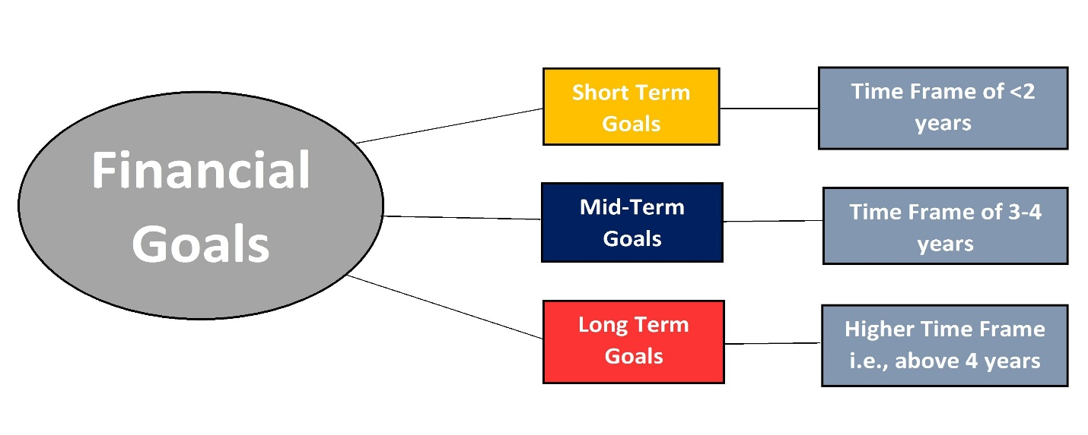
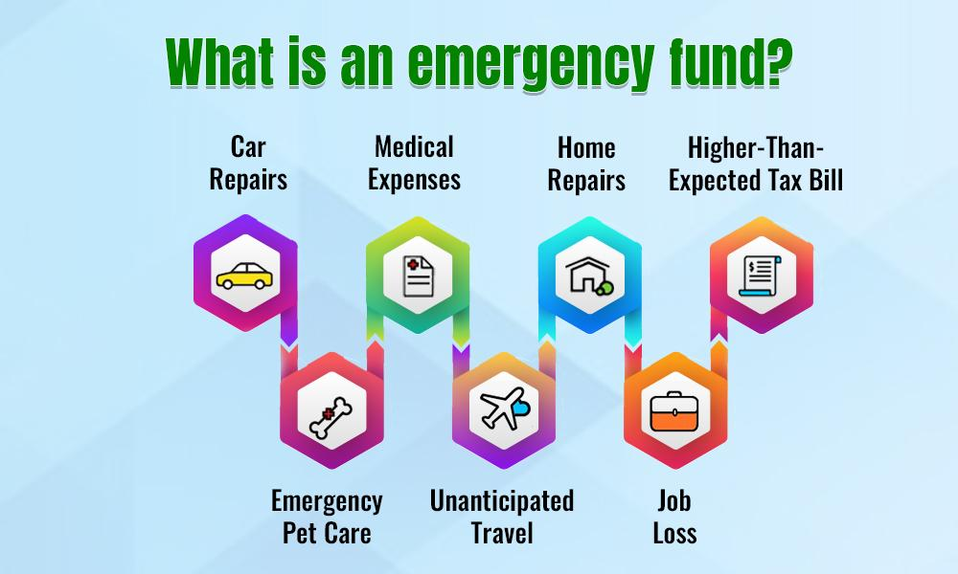
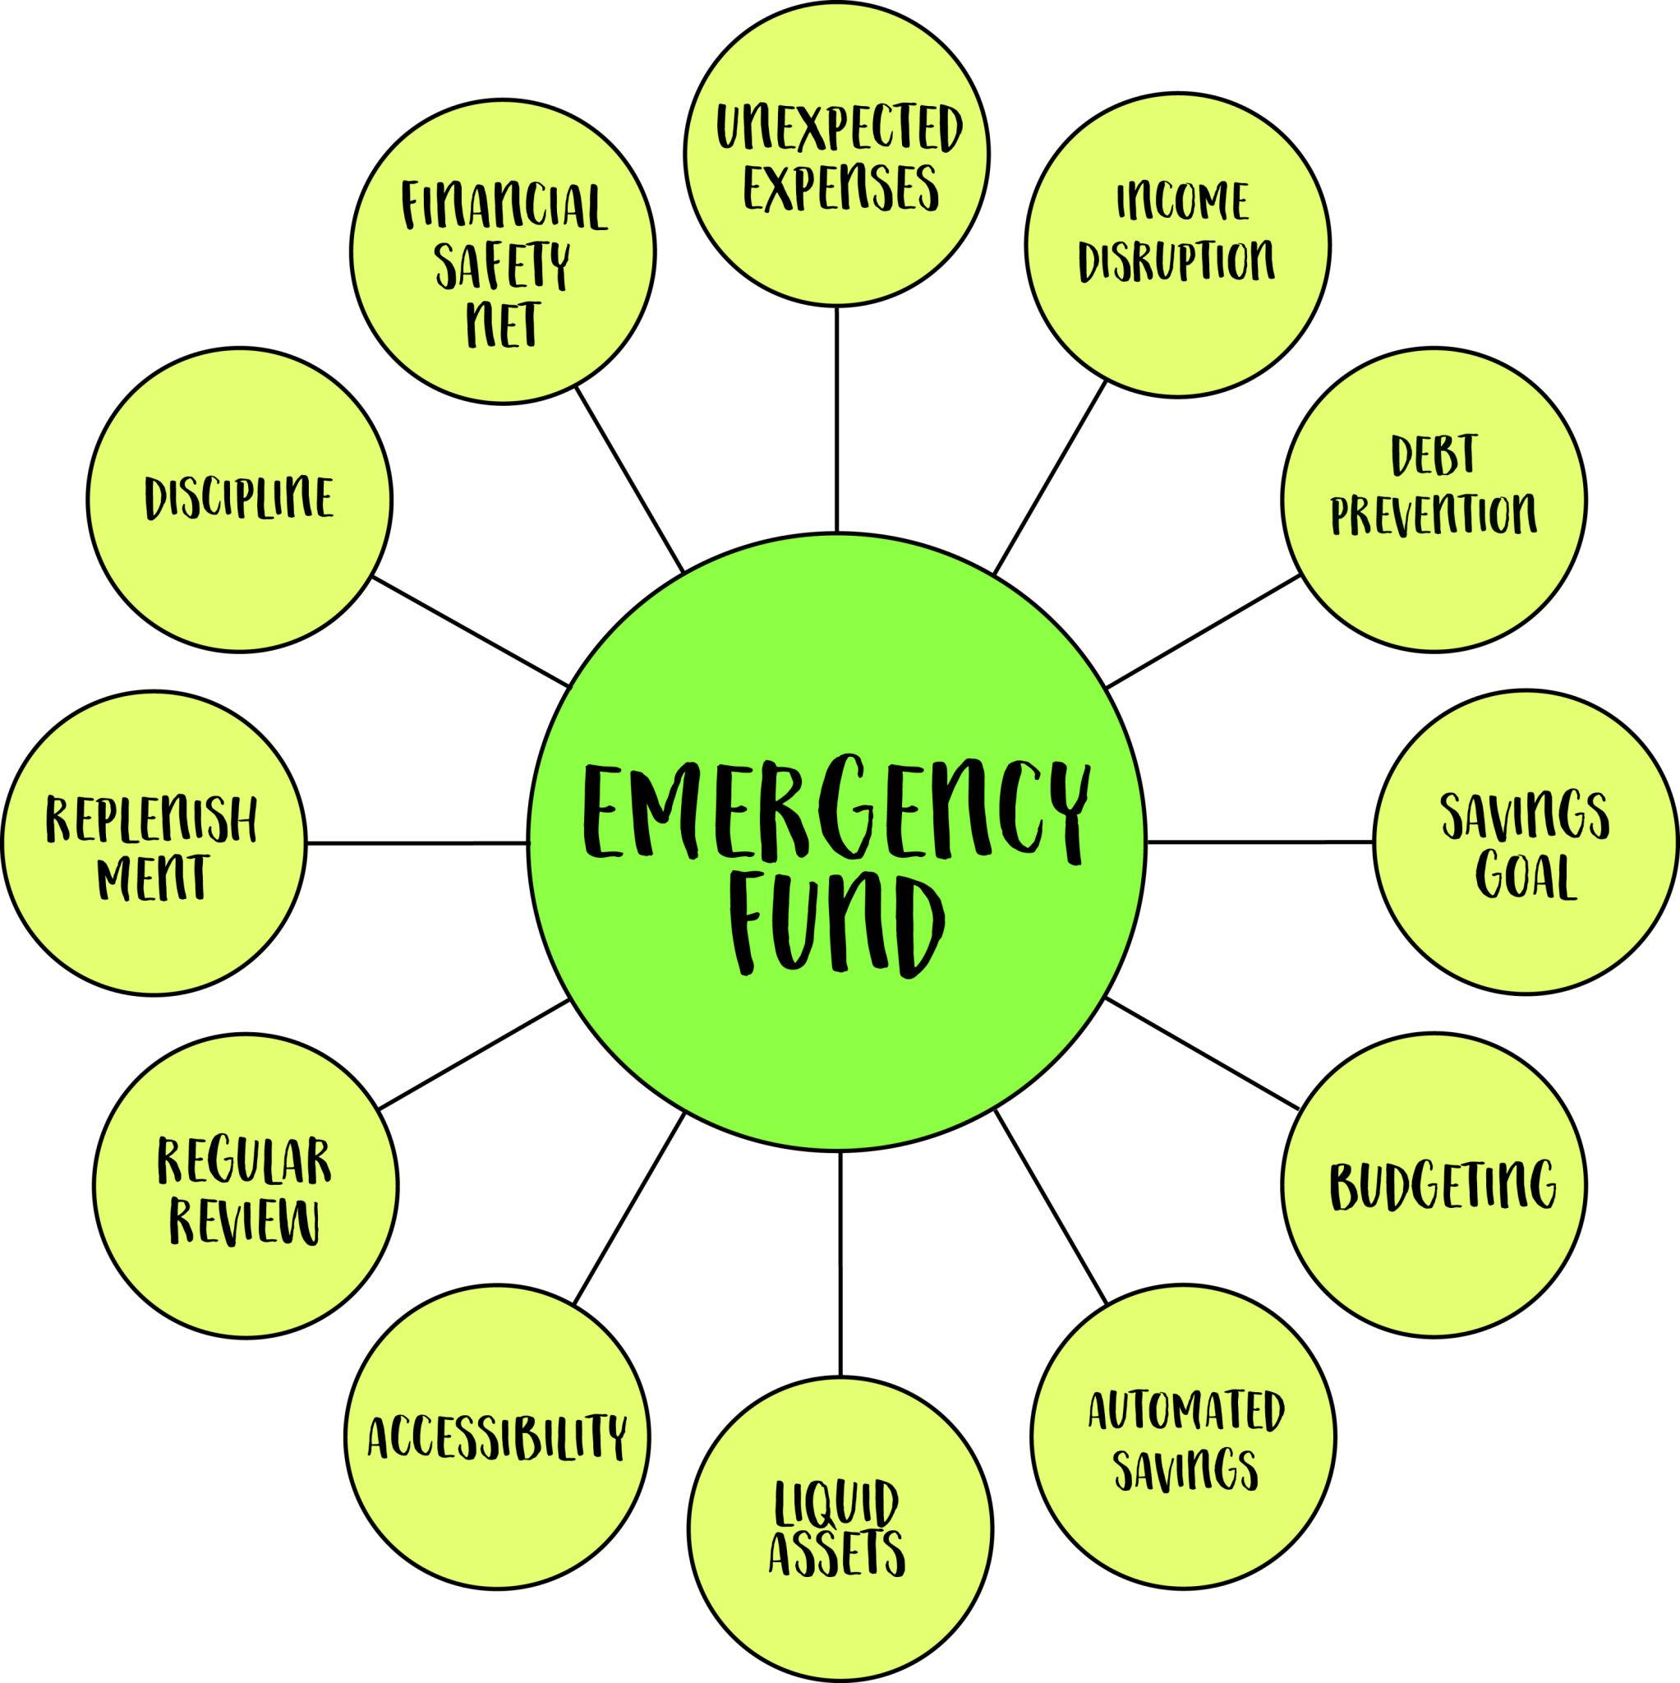
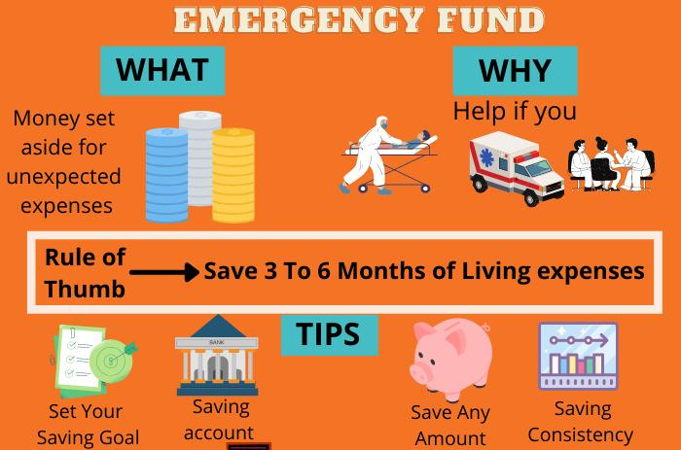
Key Concepts
- Budgeting & goal setting
- Life-stage planning
- Emergency planning
Flowchart: Financial Planning Cycle
Income → Budgeting → Saving → Investing → Wealth Creation → Financial Security
Diagram: Life Cycle Planning
Education → Career → Family → Assets → Retirement

Module 5 (Extended): Technology in Finance – Do’s & Don’ts
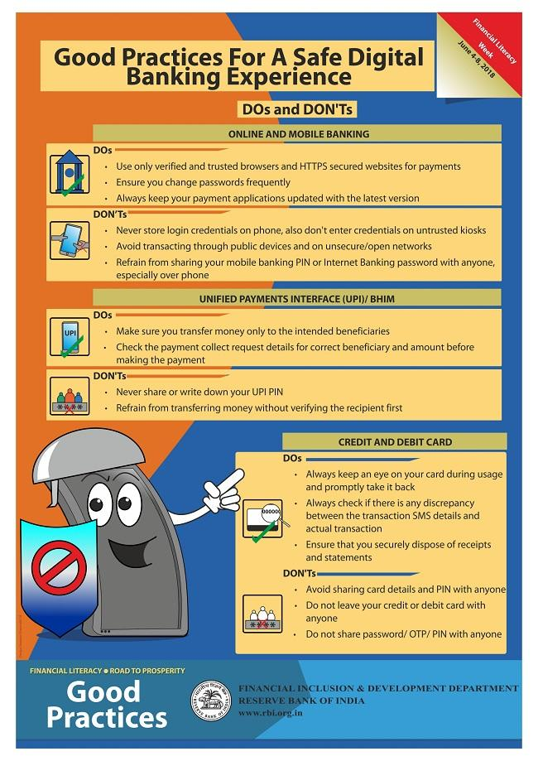
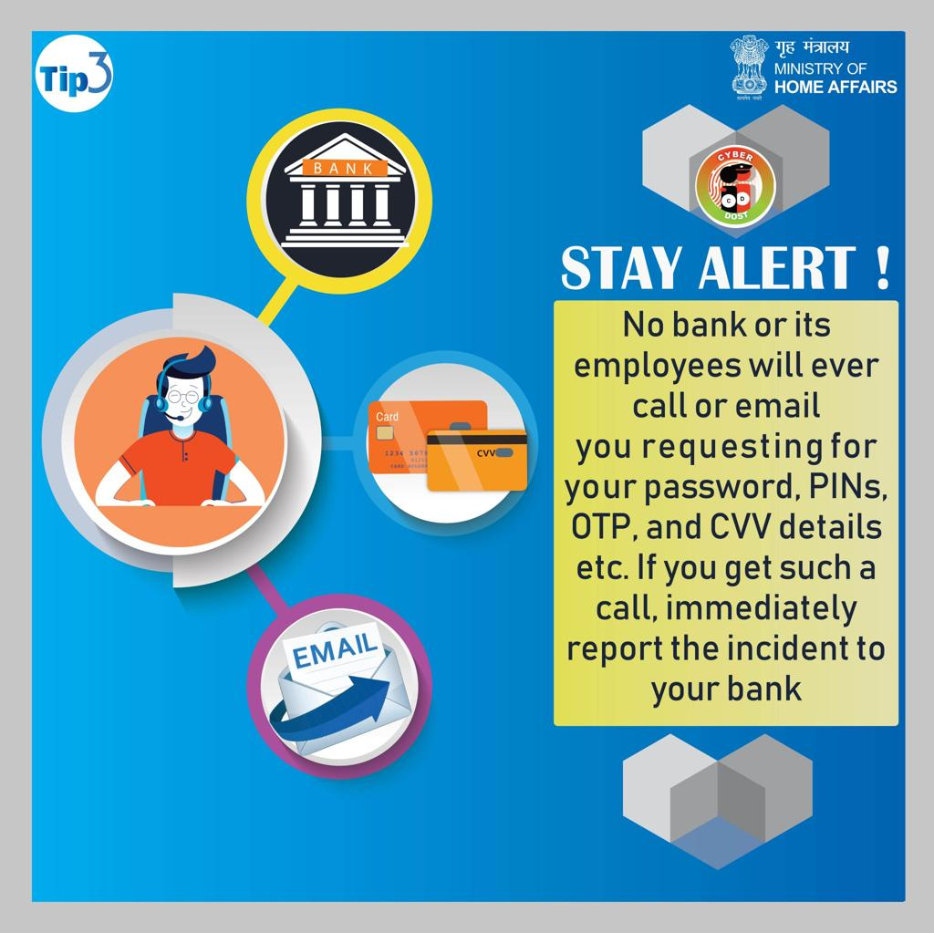
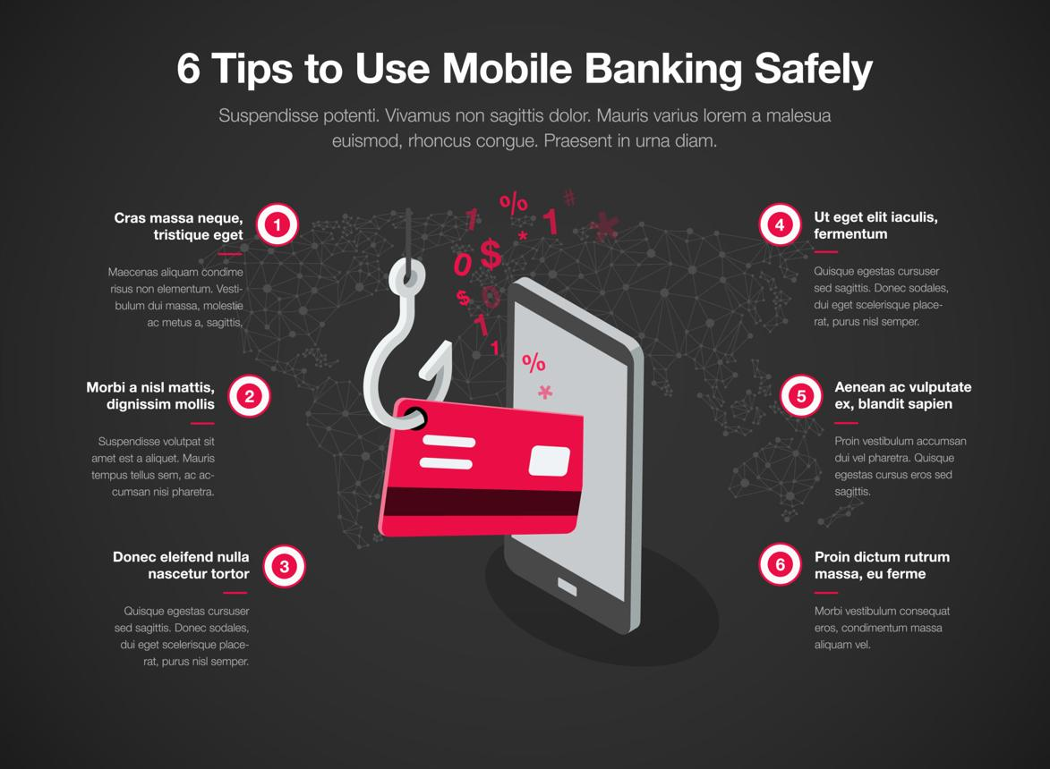

Do’s (Safe Financial Practices)
- Use strong and unique passwords for banking and financial apps
- Enable Two-Factor Authentication (2FA) for extra security
- Always access banking websites through official apps or secure links (https)
- Regularly check bank SMS and email alerts
- Update your apps and devices regularly for security patches
- Register your mobile number with the bank for transaction alerts
- Log out from financial accounts after every session
- Use trusted platforms for online trading and transactions

Don’ts (Unsafe Financial Practices to Avoid)
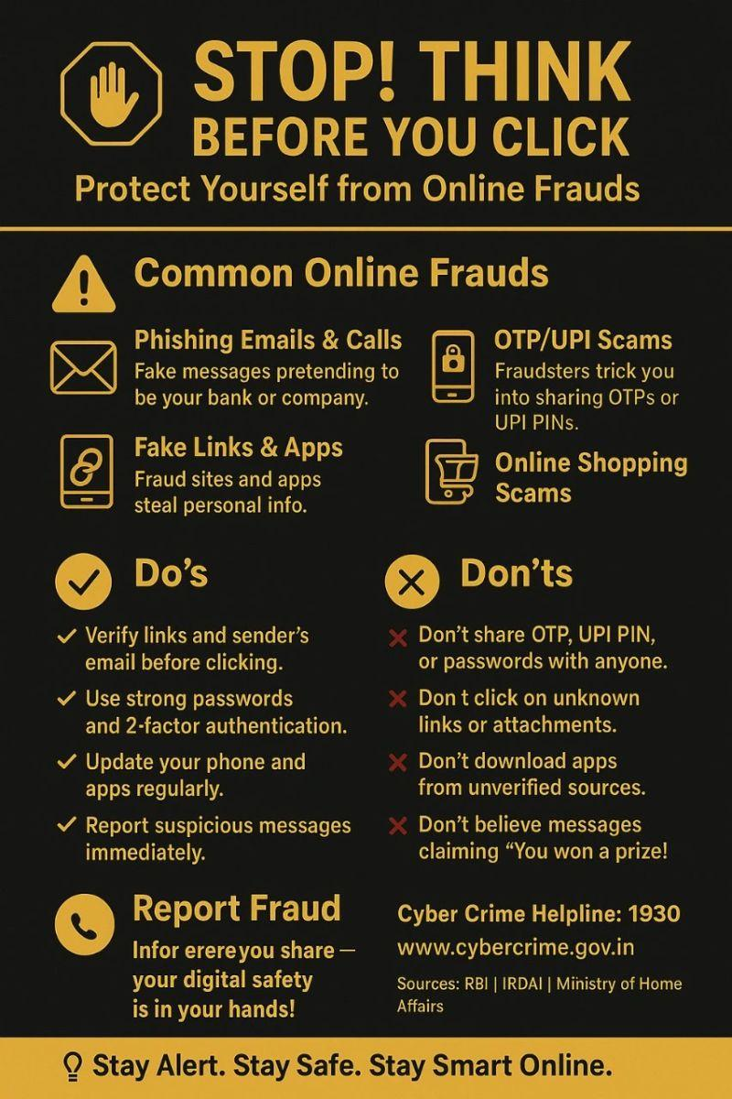


5
- Never share OTP, PIN, or passwords with anyone
- Avoid clicking on unknown or suspicious links/messages
- Do not use public Wi-Fi for financial transactions
- Do not ignore unauthorized transaction alerts
- Avoid saving passwords on shared or public devices
- Do not trust fake calls claiming to be bank officials
- Never install unknown apps asking for financial access
- Do not share your card details or CVV openly

Quick Safety Flowchart
User Action → Check Source → Secure Platform → Authenticate (OTP/2FA) → Complete Transaction Safely

Learning Outcome
Students will:
- Understand digital financial risks and frauds
- Develop safe online financial habits
- Learn to protect personal and banking information
- Become digitally responsible financial users

Module 6: Financial Documentation & Compliance
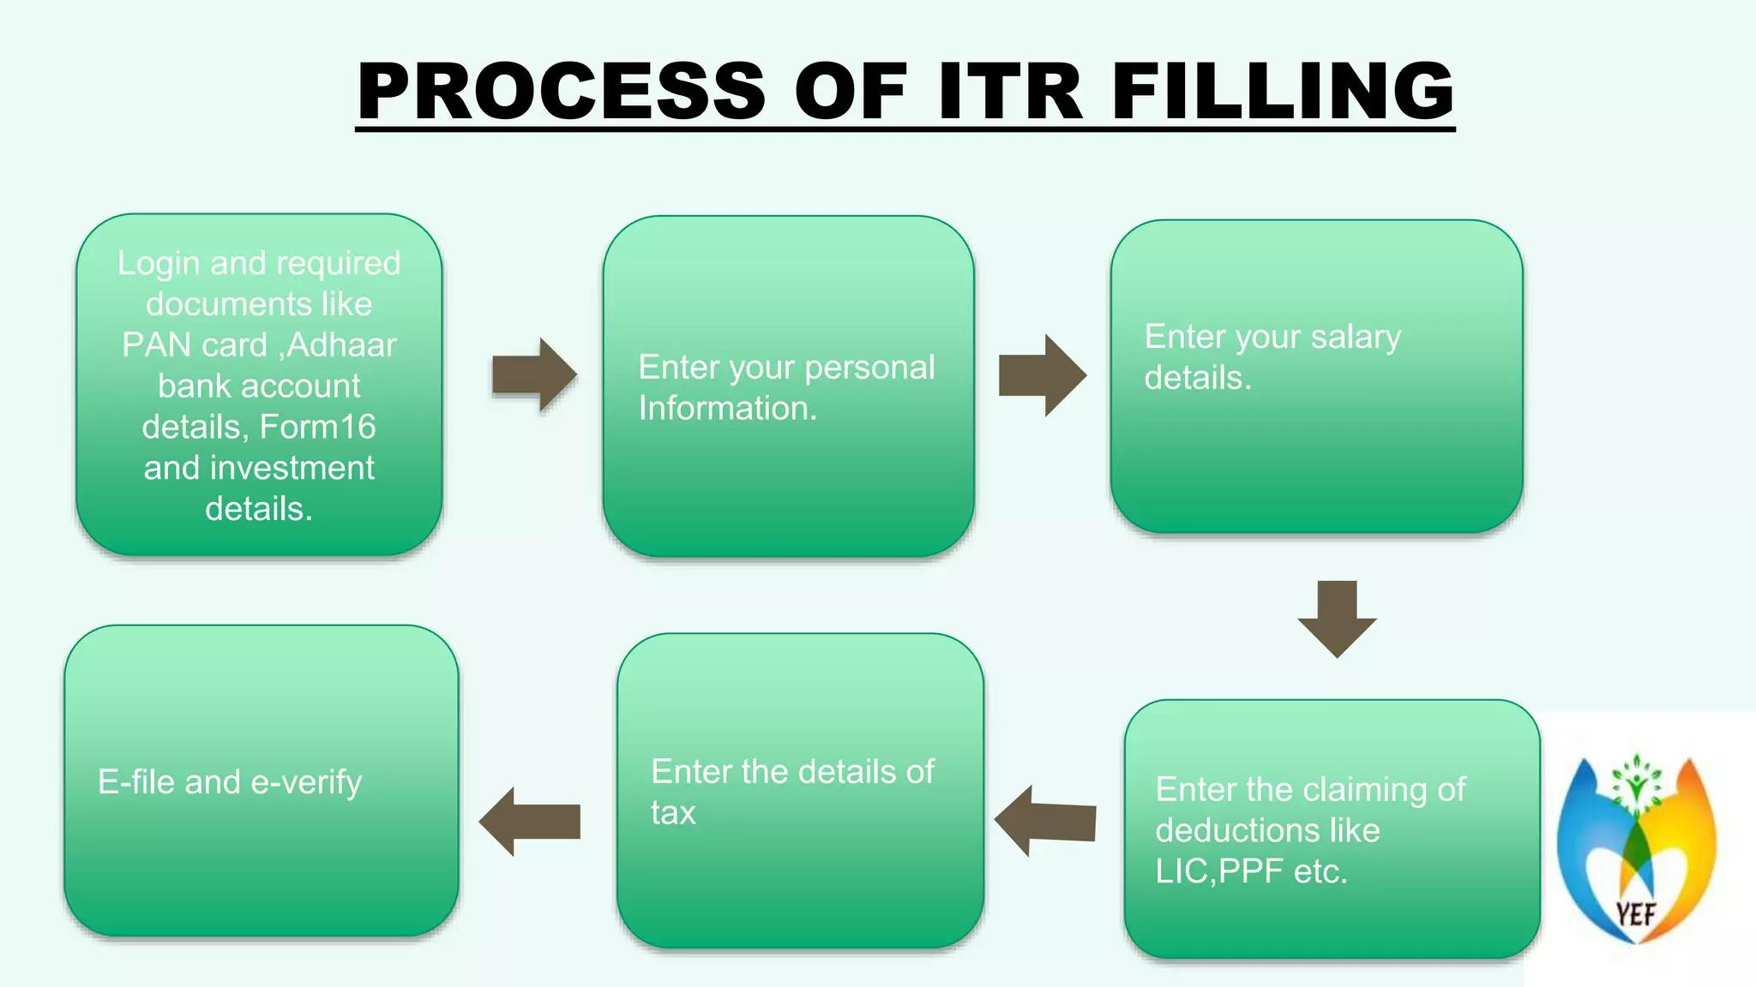
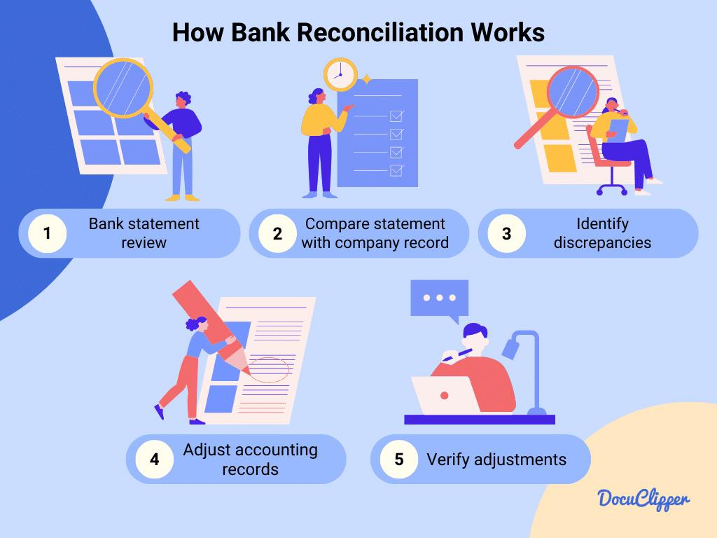
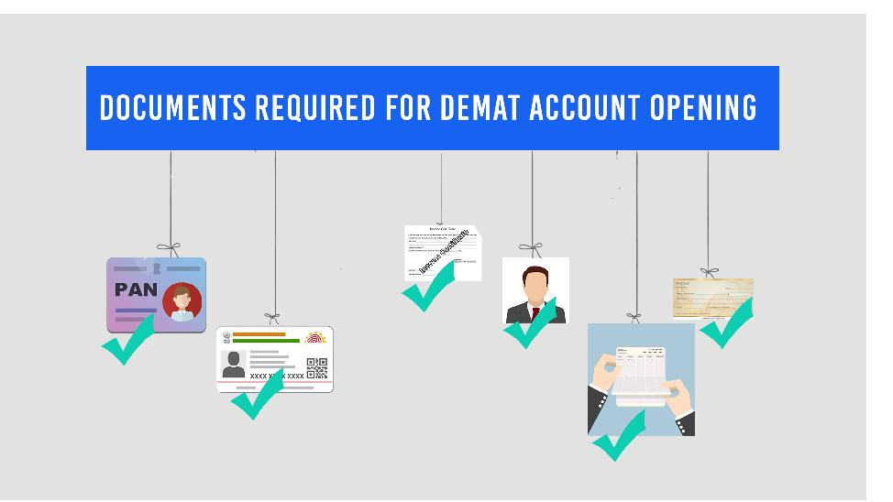
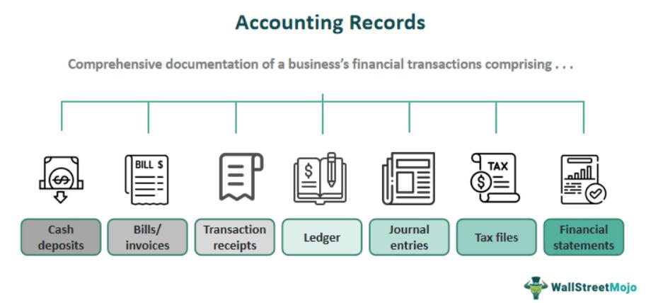

Key Concepts
- Financial records & compliance
- PAN, Aadhaar, Demat
- Tax & documentation
Flowchart: Financial Documentation
Identity Proof → PAN → Bank Account → Demat Account → Tax Filing → Record Keeping
Diagram: Compliance Importance
Proper Records → Transparency → Legal Safety → Financial Stability

🎯 Visual Learning Advantage
Improves conceptual clarity
Makes learning interactive and engaging
✔ Helps students remember concepts easily
✔Bridges theory with real-life application

Program Outcomes
Upon successful completion, participants will:
- Demonstrate a clear understanding of financial systems and instruments
- Develop practical financial management skills
- Exhibit responsible financial behavior and decision-making ability
- Gain early exposure to financial markets and career opportunities
- Build a foundation for long-term financial independence

Certification
Participants who successfully complete the program will be awarded a:
“Certificate in Financial Literacy & Securities Market Awareness”
jointly issued by SGT University and LexFin

Program Structure
- Duration: 4 Weeks / 7 Weeks
- Mode: Residential (On-Campus)
- Eligibility: School Students (Classes 8–12)

Why This Program is Important
In today’s rapidly evolving financial landscape, early financial education is essential. This program empowers students to:
- Make informed financial decisions
- Develop analytical and critical thinking skills
- Understand the practical implications of economic concepts
- Prepare for future academic and professional pursuits in finance

Admissions & Enquiries
Begin your journey towards financial awareness, independence, and professional growth with SGT University.

